Face Detection Attendance System

S. R. S. Report – I

Group No.-

1. Umesh Singh(161500595)

2. Rahul Sharma(161500427)

3. Rajan Sharma (161500430)

4. Sachin Garg(161500469)

**Table of Contents**

Revision History ii

Document Approval ii

1. Introduction 1

1.1 Purpose 1

1.2 Scope 1

1.3 Definitions, Acronyms, and Abbreviations 1

1.4 References 1

2. Analysis Models 4

2.1 Sequence Diagrams 5

2. 2Data Flow Diagrams (DFD) 5

2.3 Architecture Daigram……………………………………………………………………………………………5

2.4 Database Diagram…………………………………………………………………………………………………5

2.5 Use case Diagram……………………………………………………………………………………………...….5

2.6 Activity Diagram………………………………………………………………………………………………..…5

2.7 Entity Relationship Diagram………………………………………………………………………………....5

# 1. Introduction

This section introduces the system requirements specification for the face recognition attendance system. A system that takes the attendance of students for classroom lecture. Our system takes the attendance automatically using face recognition. Face detection and recognition module detects faces from the image captured by the camera, and the image of the face is cropped and stored.

## 1.1 Purpose

We propose a method that takes the attendance using face recognition based on continuous observation. In this paper, our purpose is to obtain the attendance, positions and images of students’ face, which are useful information in the classroom lecture. In this paper, we propose a method for estimating the attendance precisely using all the results of face recognition obtained by continuous observation. Continuous observation improves the performance for the estimation of the attendance We constructed the lecture attendance system based on face recognition, and applied the system to classroom lecture. This paper ﬁrst review the related works in the field of attendance management and face recognition. Then, it introduces our system structure and plan. Finally, experiments are implemented to provide as evidence to support our plan. The result shows that continuous observation improved the performance for the estimation of the attendance.

## 1.2 Scope

The software is to provide an easy way to mark attendance of the student. The software will allow administrators enroll student. The software will allow student have their face captured for attendance marking purposes. Only administrators will have direct manipulation rights to the system. Student will have no other interaction with the system except for having their faces captured. It will be a console application and would require maximum uptime due to its sensitive purpose.

## 1.3 Definitions, Acronyms, and Abbreviations

**DEFINITION**

Face recognition is an essential field in many applications, one which is Attendance Management System. Now days taking the attendance of the student in the classroom had became a tedious job for teachers like calling out their names waiting for response and also maintaining this attendance till the month to generate attendance report. Thus face detection and recognition module detects faces from the image captured by the camera, and the image of the face is stored. This system is divided into two main sections which will be discussed later. They are briefly shared below for introducing them. The First is Face Detection; this system includes detection of human face through a high definition camera where detection of images is done using a well-known algorithm called Viola Jones Algorithm for face detection. This algorithm helps in eliminating the issues of scaling,

**ACRONYM**

**ML:** MACHINE LEARNING

Machine learning is an AI technique getting significant attention today. The ultimate aim of machine learning is to enable software applications to become more accurate without being explicitly programmed.

**SQL:** SQL (Structured Query Language)

SQL is a standardized programming language used for managing relational databases and performing various operations on the data in them.

**TOOL USED**

**APPLICATION ARCHITECTURE-**Python

Machine Learning

Open CV

SQL

Python-Python is an interpreted, object-oriented programming language similar to PERL, that has gained popularity because of its clear syntax and readability.

Python is said to be relatively easy to learn and portable, meaning its statements can be interpreted in a number of operating systems, including UNIX-based systems, Mac OS, MS-DOS, OS/2, and various versions of Microsoft Windows

Machine Learning-Machine learning is an artificial intelligence (AI) discipline geared toward the technological development of human knowledge . Machine learning allows computers to handle new situations via analysis, self-training, observation and experience.

Open CV-OpenCV (Open Source Computer Vision Library) is an open source computer vision and machine learning software library. OpenCV was built to provide a common infrastructure for computer vision applications and to accelerate the use of machine perception in the commercial products.

SQL-SQL (Structured Query Language) is a standardized programming language used for managing relational databases and performing various operations on the data in them. Initially created in the 1970s, SQL is regularly used by database administrators

## 1.4 References

[1] K. Cheng, L. Xiang, T. Hirota and K. Ushijima, “Eﬀective Teaching for Large Classes with Rental PCs by Web System WTS,” in Proc. Data Engineering Workshop 2005 (DEWS2005), 2005, 1D-d3 (in Japanese). [2] W. Zhao, R. Chellappa, P. J. Phillips, and A. Rosenfeld, “Face recognition: A literature survey,” ACM Computing Surveys, 2003, vol. 35, no. 4, pp. 399-458. [3] S. Nishiguchi, K. Higashi, Y. Kameda and M. Minoh, “A Sensor-fusion Method of Detecting A Speaking Student,” IEEE International Conference on Multimedia and Expo (ICME2003), 2003, vol. 2, pp. 677680. [4] R.E. Burkard and E. C¸ela, “Linear Assignment Problems and Extensions”, In Handbook of Combinatorial Optimization, Du Z, Pardalos P (eds). Kluwer Academic Publishers: Dordreck, 1999, pp. 75-149.

**SOFTWARE REQUIREMENT :**

* Software Development Kids(SDK)
* Security
*  Windows7 or higher, SQL and visual studio.

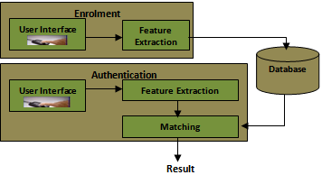

## 

**HARDWARE REQUIREMENT :**

* Laptop i3 generation
* RAM(Min. 4GB)
* PC Web Camera

**CONSTRAINTS**

* Login and password is used for the registration of users
* Only registered student will be marked present/absent
* System will detect the user’s face.

# 2.Analysis Models

## Throughout the testing period, we observed the following problems in a system:

Algorithm used for face detection:

Haar Like feature was used throughout our system for face detection respective of the algorithm used.This algorithm worked with 100% accuracy under ideal condition for face detection.

1. Principal Component Analysis(PCA):

Face Detection Accuracy:100% throughout the testing period under ideal conditions.

Face Recognition Accuracy:90% per 10 phases in the database.

1. Linear discriminant analysis(LDA):

Face Detection Accuracy:100% throughout the testing period under ideal conditions.

Face Recognition Accuracy:70% per 10 phases in the database.

## 2.1 Sequence Diagrams

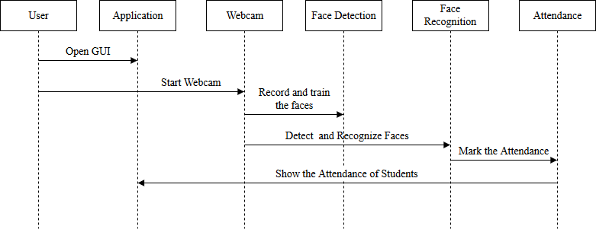

## 

## 2.2 Data Flow Diagrams (DFD)

## Screenshot (292).png

**2.3 ARCHITECTURE DESIGN**

SYSTEM ARCHITECTURE

System Architecture describes the various tiers of a system (Data, Logic and Presentation). The data tier describes the raw untouched unmodified data contained within the system which in our system was developed with Microsoft SQL Server.

The Logic tier represents the use of the data to make the system work and feed the system with the necessary data needed to work. These include the attendance marking, payroll

calculation and enrolling new employees. This was achieved using python and an open source library Emgu.cv.

The presentation tier refers to the specific view a user wants to see. These include querying the database for reports and showing relationships between entities. Visual studio Windows Form Applications helps us to design these presentations.



**2.4 DATABASE DESIGN**

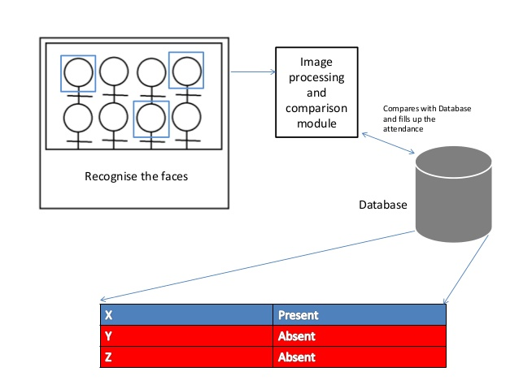

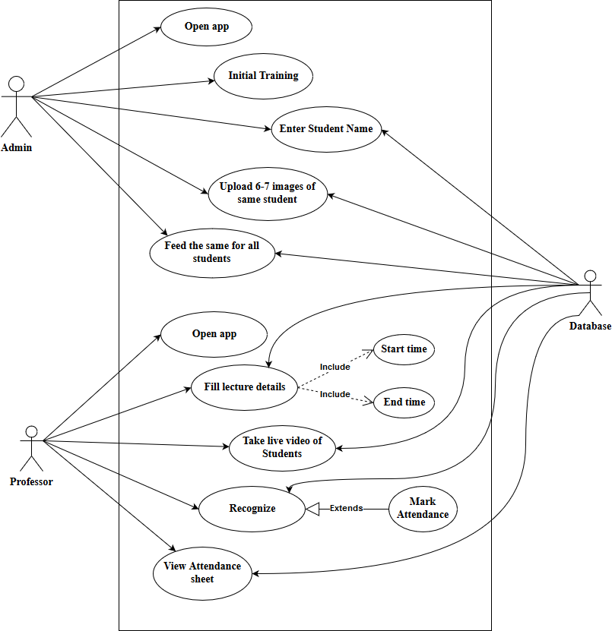 **2.5Use Case Diagram**

## 2.6 Activity Diagram

## 2.6 Entity Relationship Diagrams (ERD)

ENTITY RELATION DIAGRAM

An entity-relationship diagram (ERD) is a type of data modeling that show a graphical representation of objects or concepts within an information system or organization and their relationship to one another. This entity relationship diagram describes an employee belonging to a department holding the admin position logging in to a user account. He can choose to make enrollment of a new employee. An employee registers attendance and his salary calculated based on attendance and Wage Per Day (WPD)

## 